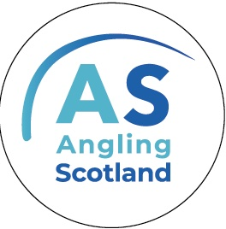
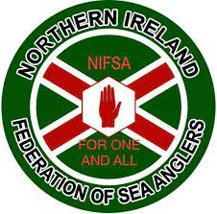
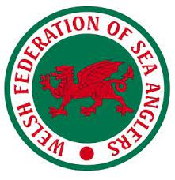
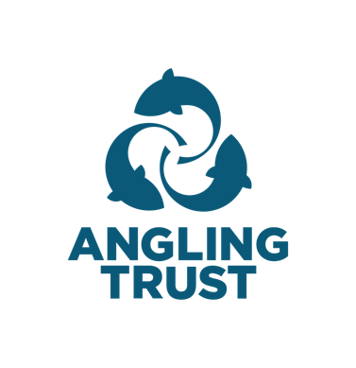

Recreational Sea Anglers Overlooked in the Joint Fisheries Statement Say Angling Bodies

In January 2022, the UK government and devolved administrations published the draft Joint Fisheries Statement (JFS), setting the future direction of UK fisheries management. A requirement of the Fisheries Act (2020), the statement (final version to be published in November 2022) aims to ensure that policies deliver a thriving, sustainable fishing industry and a healthy marine environment.

Within the draft Joint Fisheries Statement, the government has missed opportunities to capitalise on the economic and social benefits sea angling can deliver. This undermines commitments set out in the Fisheries Act (2020) for the sector and adds to the ongoing marginalisation of sea angling interests and their benefit to society and the economy.

Each year, sea anglers spend up to £1.3 billion, generating a direct impact of up to £847 million. In 2016-17, this resulted in a total economic benefit of £1.6- £1.9 billion, supported 13,600-16,300 jobs, and created £696-£847 million Gross Value Added (GVA), according to Sea Angling 2016-17. Between 2016 and 2019, the Watersports Survey estimated that between 551,000 and 902,000 people participate in sea angling each year, fishing for 6 to 7.5 million days annually.

Sea angling supports vital jobs and communities, especially within marginalised and vulnerable coastal communities that have struggled to remain viable with the ever-increasing social and economic pressures put upon them. Successive governments have struggled to manage these difficulties, with once vibrant communities continuing to decline speedily. Sea angling can work hand in hand with other sectors such as commercial fishing to be an important economic and social tool to support regeneration in these fragile areas and should be supported and promoted by the government in this regard.

Sea angling data can also support local, national, and regional management of fish stocks, environmental protection, marine spatial planning, development of the blue economy, and physical health and wellbeing. The sport is more than a pastime. It is people’s livelihoods.

For the Joint Fisheries Statement to adequately address the role of Sea Angling and ensure its maximum benefit to wider society, we are asking that the Joint Fisheries Statement:

- Addresses the Fisheries Act (2020) commitment to support the “promotion and development of recreational sea angling.”
- Engages with the recreational sea angling sector through co-design and co-management, where applicable, from the onset of management development
- Makes more substantial commitments to embed recreational sea fishing within fisheries management and reflects the sector’s interests
- Supports investment into the socioeconomic contribution of recreational sea angling locally, regionally, and nationally
- Recognises the role recreational sea angling can play in gathering high-quality data on data-poor species to facilitate more robust fisheries management

Stuart Singleton-White, Head of Campaigns at the Angling Trust, said, “For too long, sea angling has got a raw deal from the government. With the Fisheries Act and the fisheries management plans that flow from that Act, this is a real opportunity to change that. What they are proposing with this draft Joint Fisheries Statement falls well short of what is needed. It fails in so many areas. We are calling on the Fisheries Minister to get a grip and ensure the contribution sea angling makes to coastal communities, to jobs, and as we come out of the pandemic, to the wellbeing of hundreds of thousands of sea anglers across the UK is properly recognised and supported.”

Alasdair Campbell, Scottish Federation of Sea Anglers, said, “This consultation offers a chance to comprehensively re-align how we manage our marine environment. Sea angling has historically provided economic and social benefits to our communities, working alongside other marine stakeholders. With the correct engagement and development, sea angling can continue to provide and enhance these benefits for all these stakeholders. Therefore, I would ask that the government look to fully recognise this contribution and enshrine engagement with the sea angling community in future legislation.”

John O’Connor, Welsh Federation of Sea Anglers, said, “Once again, it is appalling that recreational sea anglers (RSA) and their worth to the economy of both Wales and the UK is ignored despite surveys in 2006 (Drew Associates) and 2015 (Bangor University, part-funded by Welsh government) showing that their contribution to the economy is some ten times greater than that of commercial fishing. Furthermore, in Wales, the only committee for the RSA voice has been disbanded, and it is hard to get Welsh fisheries to listen, as evidenced in recent discussions regarding the CHART Tuna programme. RSA could be the guardians of the aquatic environment through their eyes and ears on and by the water. The powers that be need to get on board the RSA pro-environment agenda rather than ignoring it to please a self-seeking, environmentally destructive minority.”

Garry Gregg, Northern Irish Federation of Sea Anglers, said, “Given the question of concern for RSA kindly raised in January this year by MP Paul Girvan and the answer by Minister of state Victoria Prentis, the food security of the UK has since become under even more severe threat because of Russia’s invasion and our fish resource being long since painfully reduced to a shadow of its once bounty - we must act quickly!

“We currently import around twice the amount of fish that we export. We must ensure UK fish security quickly. A good start would be to reinstate the UK three-mile limit ban on all mobile gear, applied in 1883 and further extended in 1889 over concerns about declining fish stocks. This was removed in 1984, and our stocks started quickly crashing after this. Currently, large swathes of our waters are devoid of fish.

“If we do not act immediately, we will see the total collapse of our commercial fishing industry, along with UK recreational sea angling which has over 900,000 participants worth £1.5 Billion per annum."

This briefing presents the collective views of the Angling Trust, Angling Scotland, the Welsh Federation of Sea Anglers, and the Northern Irish Federation of Sea Anglers.

For further support, please contact:
- Hannah Rudd, Angling Trust
- Alasdair Campbell, Angling Scotland
- John O’Connor, Welsh Federation of Sea Anglers
- Garry Gregg, Northern Irish Federation of Sea Anglers

